THE HISTORY OF CRAMOND KIRK

 | Cramond was originally Caer Amon the fort on the River Almond. You will recognise Caer as a regular prefix in Welsh place names, eg Caernarvon, so why does it appear in Scotland?  At the time when the Romans built the fort on the River Almond (AD142), English, Welsh and Scots did not exist. They were all British and spoke a language akin to Welsh. The local people called themselves the Gododdin and the Romans called them the Votadini.
  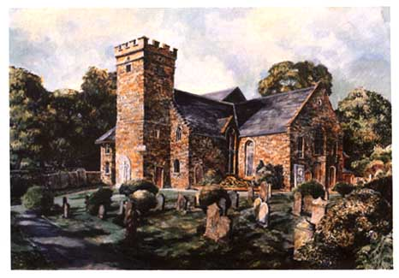
In the course of the next century the Romans departed but there were many more invasions to come. In AD638 the Angles (from north-west Germany) captured the fortress which the British called Din Eidyn; they renamed it Edinburgh. It is to them that we owe the word Kirk for the Church.

Historical Features within the Kirk

The tower is the oldest part of the building, dating back to the 15th century although the parapet was not added until 1811. The bell, which is still rung before the 11 am service on Sundays, has had an exciting history. Like many other Scottish bells of the 17th century, it was made in Holland, a country of fellow Calvinists.  When Oliver Cromwell invaded Scotland in 1651, his soldiers made off with Cramond Kirk’s bell. However, as the kirk’s record shows, “after much solicitation employed and interest made Cromwells General Monk agreed to arrange for its return.”  If you had come through the tower door in 1475 you would have seen not one altar in the east of the kirk, but two. One was dedicated
  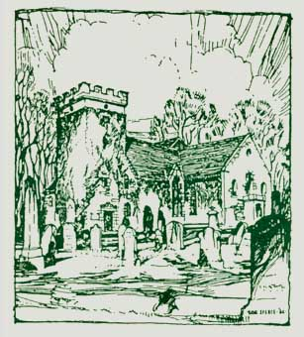
to the Virgin Mary, the other to St Columba who brought Christianity to Scotland in the 6th century. You would also have heard chaplains saying Masses.

There have been a few changes since then. For one thing, we no longer talk about altars but about the Communion Table. For another, the Kirk has had a lot of alterations since an almost total ruin was rebuilt in 1656.

The third thing was the Reformation of 1560 when the Church in Scotland decided to recognise no longer the sovereignty of the Pope but instituted its own (Presbyterian) form of government. The Inglis family vault is the other part of the kirk which was in existence at the 1656 restoration. It is the building with the stone slabbed roof which you pass on the way to the car park. The Craigie Halkett family were the last owners of Cramond House; the last occupant was Miss Dorothy Craigie Halkett (1893-1959) whose memorial stone you may be able to make out at the far end of the Inglis vault.
WEST & EAST AISLE

The first memorial along the west aisle towards the north gallery is to Lieutenant Hamish S Mackay of Whitehouse. Next is a stained glass window in memory of Robert Wilson of Inveralmond.
The mansion of Inveralmond is now demolished but its name lives on in roads off Whitehouse Road. The last owner of Inveralmond was Captain Salvesen who donated the steps on the riverside walk north of the weir.
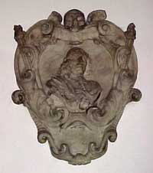
The ship at the top of the window symbolises the mission of the Church to preach the gospel to all nations. You will find the symbol repeated in the pulpit fall and the war memorial mosaic.

To the left of the window is a bust of Sir James Hope, builder of Hopetoun House, who died on 27 November 1661. His elaborate tomb is on the outside wall.

The wooden board contains the names of the ministers of Cramond Kirk since the Reformation. A remarkable trio served in the 18th century – William Hamilton (1694-1709) and his sons, Robert and Gilbert. All three became Moderators of the General Assembly. Robert Walker (1776-1784) became known as the Skating Minister, his portrait by Henry Raeburn hangs in the National Gallery.

Across the kirk in the east aisle is another stained glass window, also in memory of Robert Wilson of Inveralmond.
The Greek words on each side translate Christ the Victor. They are repeated on the war memorial.

THE KIRK'S WINDOWS
At the back of the kirk

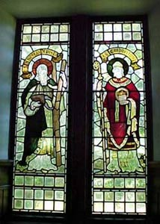 | 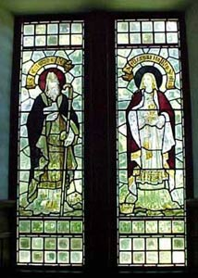
The painted glass windows below the north gallery depict four saints who have influenced Scottish religious life. It would be incorrect to describe them as Scottish saints since they are, from left to right, a Galilean, a Scotsman, an Irishman and an Englishwoman.
St Andrew: the patron saint of Scotland, was the brother of St Peter and his connection with Scotland is that St Rule brought some of his relics from Constantinople to St Andrews in the 8th century.
St Cuthbert: the Bishop of Durham in Northumbria which in his day extended to the Firth of Forth. He died in AD 687. Many Scottish churches are dedicated to him.

St Columba: came from Ireland in AD 563 and landed on the island of lona from where his missionaries travelled to preach to the Picts and Scots.
St Margaret: great niece of Edward the Confessor. Driven into exile by William the Conqueror, she landed by chance in south Fife. King Malcolm Canmore (son of the Duncan who was slain in battle by Macbeth) came to greet the noble refugees, fell in love with Margaret and married her in 1070. She is remembered for her piety, good works and the institution of the ferry crossing known as the Queensferry Passage which persisted for 900 years until the building of the Forth Road Bridge in 1964.
The inscription on one window tells us that it was gifted by E & A W W in celebration of 38 years of happy marriage. The initials stand for Elizabeth (nee Croall) of Craigcrook and (Dr) Andrew Wallace Williamson who were married in Cramond Kirk in 1888. The windows were in Dr Williamson's study when he was Minister of St Cuthberts in the West End of Edinburgh. In 1910 he became Minister of St Giles, where the service is held which begins every Edinburgh Festival. He retired in 1925 and died in 1926. His widow gave the windows to Cramond Kirk in 1930.
THE CHANCEL
At the front of the kirk

The Communion Table shows a carved cross surrounded by a circle, the circle being the Celtic symbol for light. Here the minister and elders sit on Communion Sundays and distribute bread and wine to the congregation.
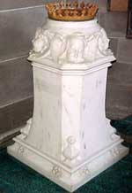

To the left is the Pulpit which dates from the 1911 refurbishment. The base and the steps are in blue Barnton stone, hewn from a long-disused quarry on the Bruntsfield Golf Course in Davidson’s Mains.

The font also dates from 1911 and the inscription, “The Gift of the Children”, records the old pennies and halfpennies given by children.

The three windows (by Morris & Co to designs by Edward Burne-Jones) above the Barnton gallery are in memory of William Reid, former owner of Lauriston Castle, and William Barton, his brother in law.
Lauriston Castle is now now held by the City of Edinburgh Council. It is in Davidsons Mains and is open to the public.

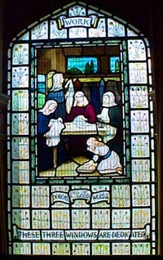 | 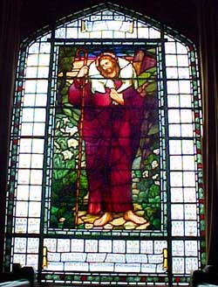 | 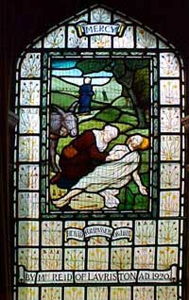
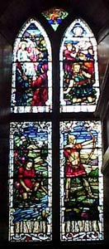
THE WAR MEMORIAL

The window is a memorial to the dead of World War I and depicts conflict and triumph. High over all is the burning bush.

The brass with its enamels of the four Evangelists (St Matthew a man, St Mark a lion, St Luke a calf, St John an eagle) contains, beside the inscription, the names of 105 men connected with our parish who died in the Great War. After World War II a further 12 names were added.
In the corner beneath the window is the motto from Horace Odes 2.6.13 which is translated “that nook of earth has charms for me over all the world beside”.

One of the names on the war memorial is connected with the gallery at the west end, the Dalmeny gallery. The Honourable Neil J A Primrose (1882 - 1917) was the younger son of the 5th Earl of Rosebery whose estate of Dalmeny lies on the far bank of the River Almond, across the ferry.

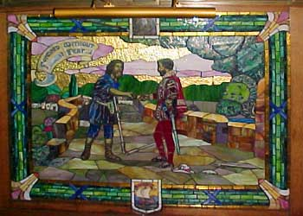 | The mosaic was gifted by the artist (Douglas Strachan) who was responsible for the stained glass window above and it recounts the legend of Jock Howieson, a peasant living at Cramond Brig, who came to the aid of a stranger being attacked by robbers and found that he had rescued his king.  To show his gratitude the king granted him the lands of Braehead in return for which he was to provide the monarch with a ewer and basin for washing his hands whenever he passed Cramond Brig.

The work of the 20th century craftsmen in stained glass below the Dalmeny gallery has been much admired. The window on the left (fashioned by Alexander Strachan in 1939) is in memory of Miss Jessie Colvin (died 1938 aged 84), younger daughter of Walter Colvin, minister from 1843 – 1877. The window on the right is in memory of Dr G C Stott who was minister of Cramond from 1910 – 1943.
  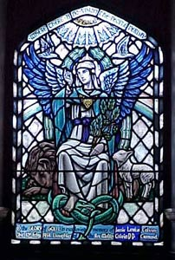
THE KIRK'S GALLERIES

In the Church of Scotland years ago only the heritors (or landowners) used the galleries "the laird's loft". Here in comfort and often with a stove sat the most important heritors (landowners) with their family and entourage while below them the ordinary folk stood or sat on stools brought with them.  The heritors were responsible for the upkeep of the kirk and manse, the cost being apportioned on the rental value of their estates. The largest by far was Barnton (bounded approximately by Quality Street, Cramond Road South, Lauriston Brae, Gamekeepers Road, Whitehouse Road and Queensferry Road) which bore 36% of the expenses.  The Barnton Gallery is above the Communion Table and Elders’ chairs. It is where the choir sits. Barnton House was demolished in 1925 and its parkland is now occupied by golf courses. In 1891 a railway line was opened from Edinburgh to Barnton after which there appeared two prestigious golf clubs, the Royal Burgess Golfing Society (from Musselburgh) and the Bruntsfield Links Golfing Society; Cargilfield Preparatory School (founded in Trinity in 1873); big houses in Barnton Avenue; sturdy villas in Barnton Gardens and what is now Cramond Road South. | 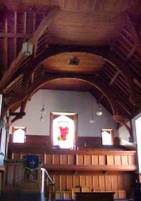
The Cramond Gallery is the one on the left hand side as you face the Communion Table. It was where the owners of Cramond House used to sit. This is the big house on the far side of the car park which was built in three stages : 1680, 1771 and 1818.

In the Cramond Gallery is a small blue velvet-covered chair which Queen Victoria sat upon whilst attending a service at Cramond Kirk. She was staying at Cramond House on her journey further north to Balmoral.

It is interesting to note that on the census night of 5 April 1891 there were 15 in the house: the tenant Mr James C Hope, a civil servant (Inland Revenue), his wife Sophia, four children aged 5 to 10 years and nine live-in employees; a governess, a cook, two nurses, a lady's maid, a laundry maid, a housemaid, a kitchen maid and a footman. At the North Gate lived the lodge keeper Betsy McKinley and her young daughter; at the Main Gate the gatekeeper, Janet Howden and a former laundress aged 71. In the Henhouse (also known as the Poultry Yard) lived the coachman, his wife, four children and his widowed father. In the Gardens lived the gardener, his wife and five children; in the Stable Yard the unmarried under-gardener aged 20.

Nowadays only the Kirk’s beadle and his wife live in Cramond House, the remainder being leased to the Scottish Wildlife Trust.

The Dalmeny Gallery, in the west of the kirk, is associated with the Dalmeny estate which is across the River Almond from Cramond village. One of the names on the war memorial relates to this gallery: the Honourable Neil J A Primrose (1882 - 1917) was the younger son of the 5th Earl of Rosebery (of Dalmeny). When Cramond Kirk celebrated its tercentenary in 1956, the 6th Earl of Rosebery read the second lesson from the lectern where an elder reads the lesson every Sunday.

The North Gallery is also the newest gallery as it was built in 1911 when the church was extended northwards, towards Cramond Glebe Road. At one time there existed a previous gallery on the north side which was damaged by fire in 1868. The heritors employed a famous architect, David Bryce, who was then engaged on building Fettes College, to devise a plan and he recommended the demolition of the old gallery, and gave the occupants special raised seats against the north wall. It is recorded that they also got a new stove place, though it is not known whether the original stove was the cause of the fire. The Dalmeny Gallery, in the west of the Kirk
Gerald F Morris
with a lot of help from Jean M Crichton

THE CHAPEL & ORGAN

The Chapel Until 1998, when most of the pews were removed from under the Cramond gallery to install a new organ console, the interior of the church had not changed since the comprehensive renovation in 1911. However, in 2003 the chapel was created to provide a multi-purpose space which could be used for the 8.45 am Morning Prayer service as well as being suitable for small weddings, funerals and baptisms. The original pews were placed around three sides of the chapel and, with the addition of chairs and stools, seating for up to 50 is now available and regularly filled on a Sunday morning.

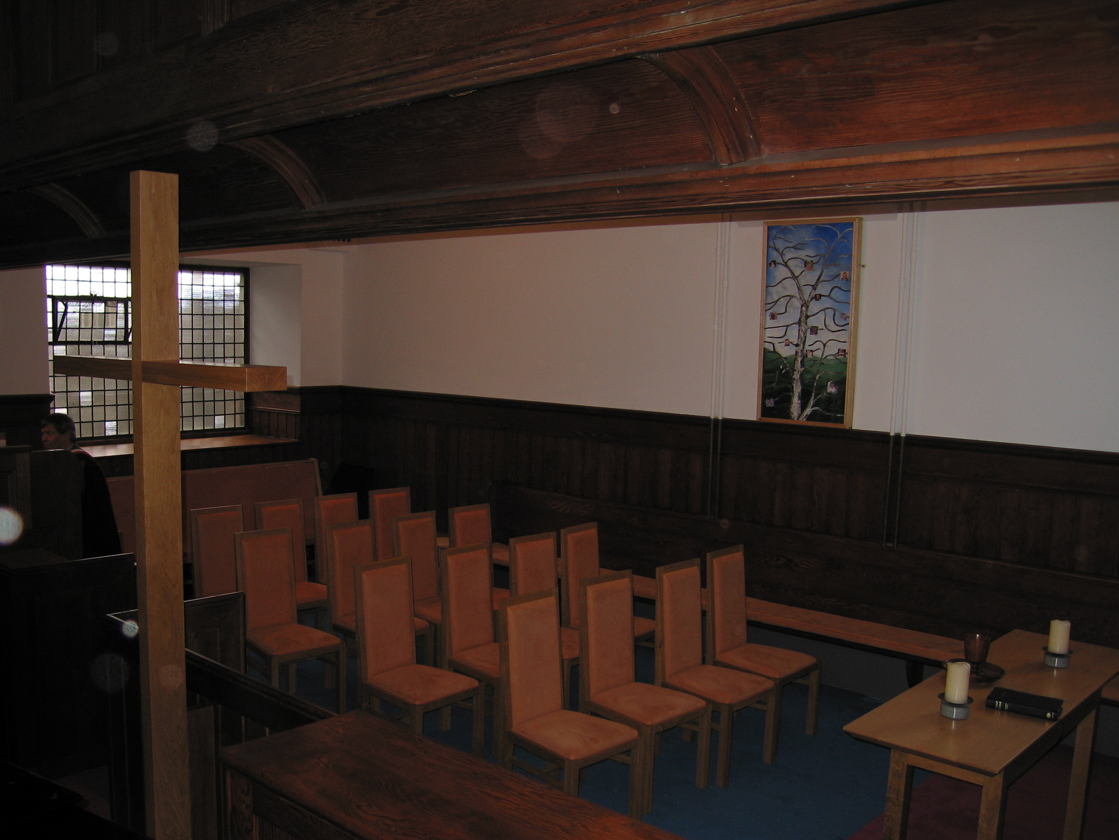
In design and detailing the interior of the kirk is Edwardian with just a hint of Art Nouveau. Furniture design, detailed by Ben Dawson of Musselburgh, is a 21st century update of that style using the same timber – oak - in the solid for the cross and in veneers for the furniture. Pine is used elsewhere, notably for the fence, the low screen defining the chapel area. The carpet, made by a Stoddard of Kilmarnock subsidiary is ultramarine in colour with a bold width of heather under the table. The two candlestick holders were turned by Kays of Scotland, Mauchline, from Ailsa Craig granite, as was the font base with its
spherical pewter bowl and cover.

A good brief is a prerequisite for creating “commodity, firmness and delight” but would St. Columba, to whom the Kirk was originally dedicated, feel at ease within the new chapel? Would he, after marvelling at the electric lighting and central heating, be at home with the space planning, the utility and the symbols of his faith which we share? Would he be delighted or would he be cross?

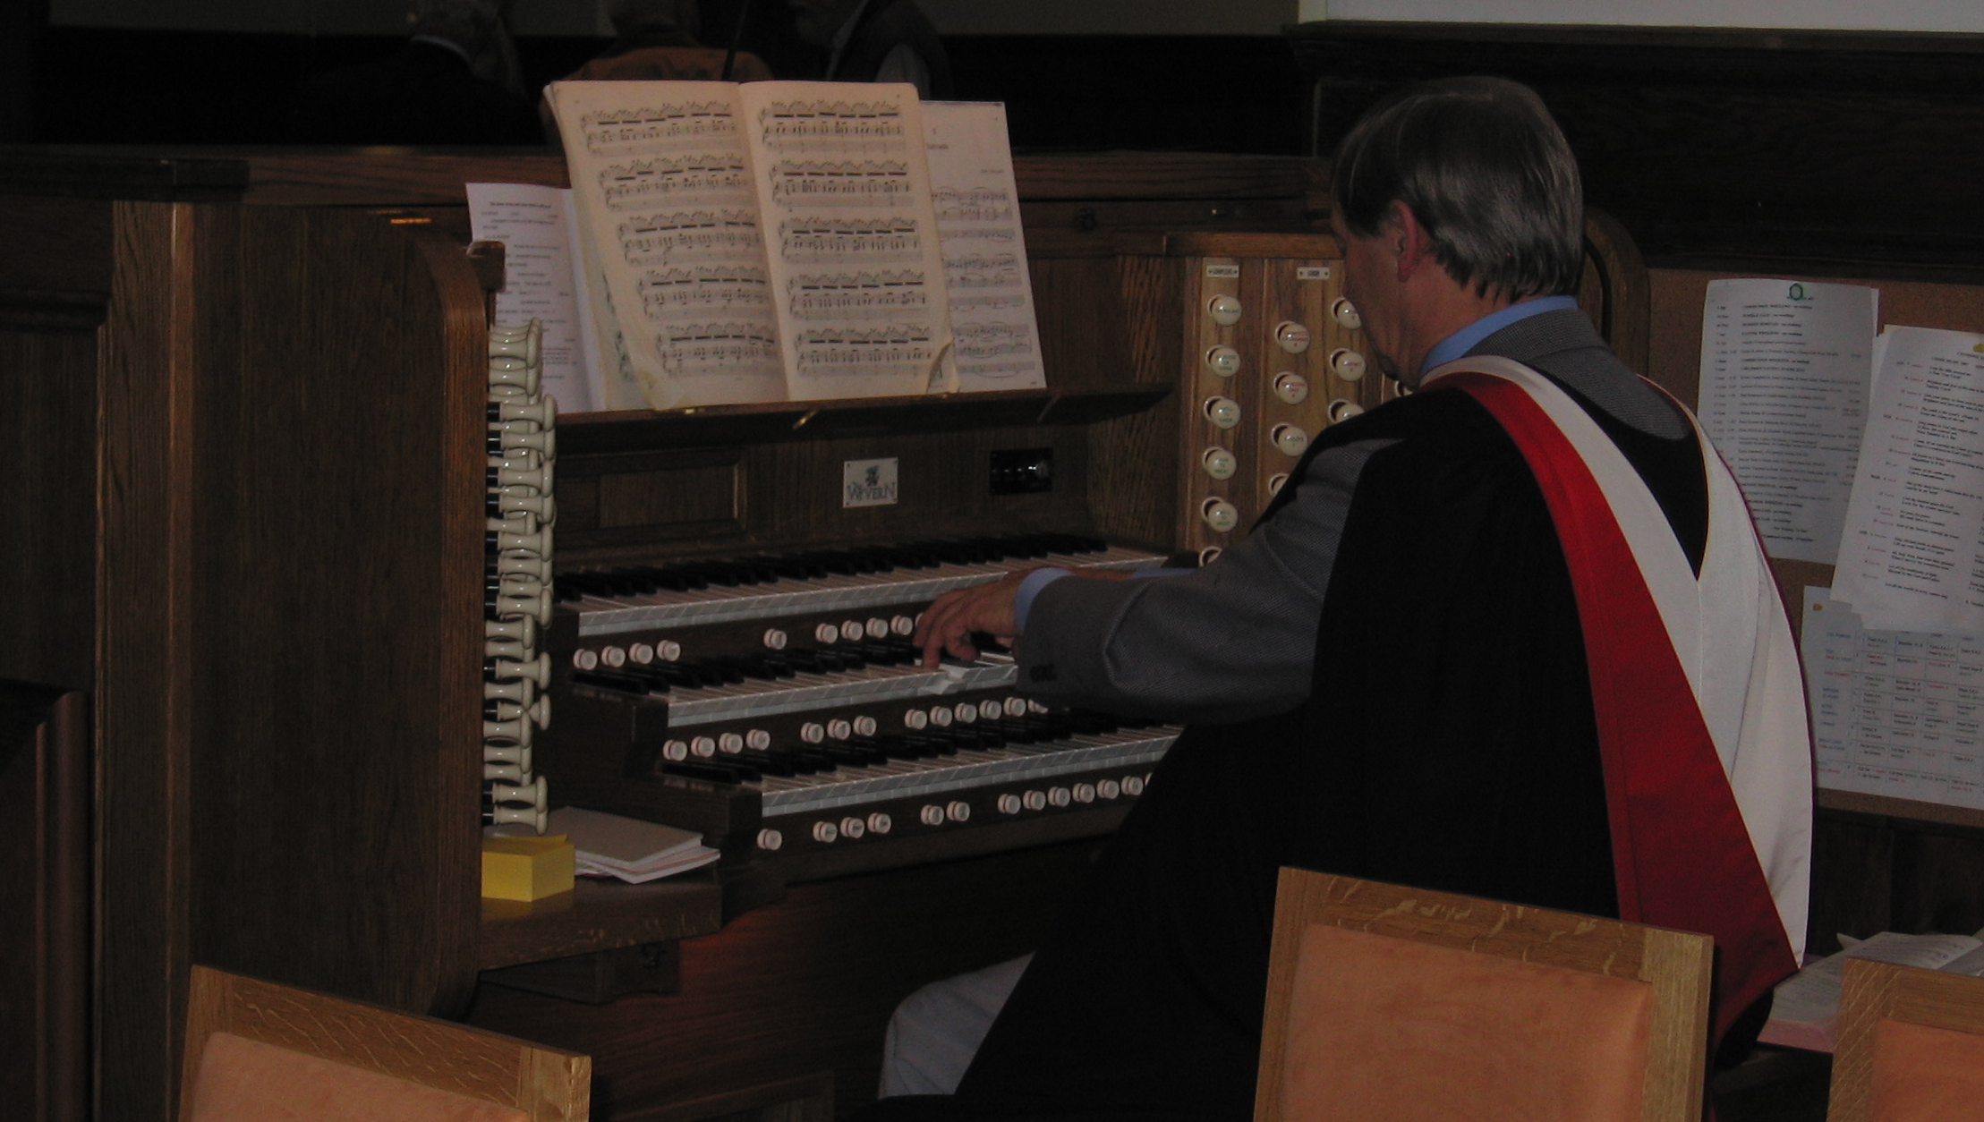
The Organ The Wyvern digital organ was installed in 1998 and the console is at the back of the chapel. The speakers are hidden behind the dummy organ pipes beside the Pulpit. Prior to the installation of the Wyvern organ, music was played on the Norman & Beard organ which dated back to 1911.

